

Water Service Line Survey
To comply with EPA regulations, public water systems are required to complete an inventory of service lines, and this survey plays a vital role in helping your public water system fulfill this obligation effectively. The following information will help you determine where your water service line is and what material the line is made of.

Find Your Water Service Line
Before completing the survey, you need to determine where the water service line is and how it connects to your home. If you need assistance finding your service line, feel free to call us 509.536.0121.
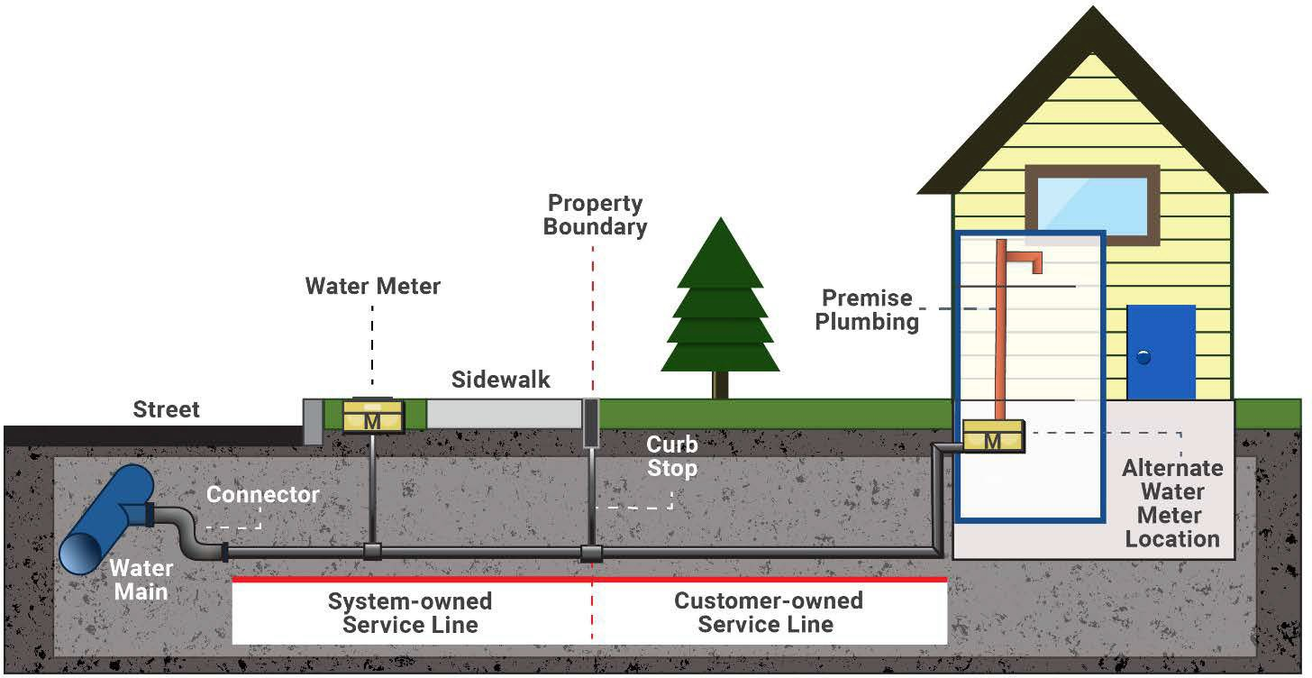

Outside Meter or Curb Stop
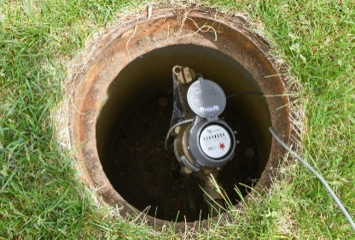
To locate where the water service line enters your home, look for a water meter or curb stop valve. These are usually found at the front of your property near the street or sidewalk and are ground-level boxes labeled "water" or "meter." Once you find them, follow the shortest path to your home. The water service line should enter the building through the floor or foundation wall in this general area.
Meter pit in yard

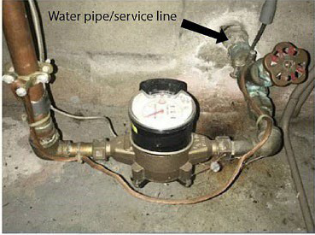
Test the Pipe Material
Once you've found where the water service line enters your home, look for a spot on the pipe closest to the wall or floor before it connects to a valve or meter. At this spot, you can test the material the pipe is made of.
In home meter
Meter pit in yard

Testing Tools
Use the following tools to determine the type of pipe material the water service line is made of.
- Refrigerator magnet—use to test if the pipe is made of steel.
- Coin or key—use to scratch the pipe to reveal the metal’s color and hardness.
- Flashlight or mobile phone—light to clearly see the pipe.
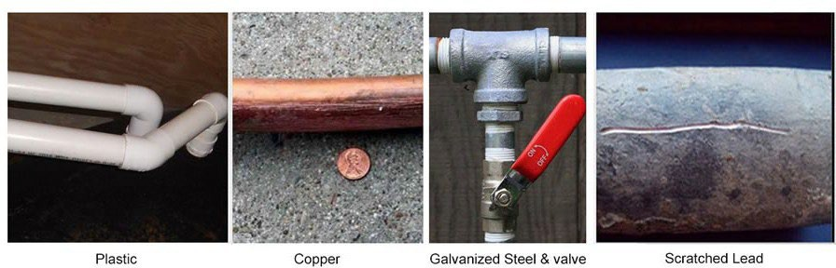

Plastic—This pipe comes in different materials and colors. If you tap it with a coin, the pipe does not make a ringing sound.
Copper—Scratch the pipe and it appears orange and shiny like a penny, which means the pipe is made of copper. Additionally, a magnet will not stick to it.
Galvanized Steel or Iron—The pipe appears silvery gray and is difficult to scratch and a magnet sticks on it. The pipe is made of galvanized steel or galvanized iron.
Lead—The pipe is silvery gray and (1) is easily scratched, (2) the metal seems soft, and (3) a magnet does not stick to it—likely lead pipe.

Water Line Service Survey
Location Information
Address: Click here to enter text.
City: Click here to enter text. | Zip Code: Click here to enter text.

Please answer the following questions:

Do you own or rent this building? |  | ☐ Own |  | ☐ Rent
What year was the building built? Click here to enter text.
To your knowledge, has the water service line for your building ever been replaced?
☐ Yes | What year was it replaced? Click here to enter text.
☐ No
☐ Not sure
What material is your water service line? You may choose more than one.
☐ Lead |  |  | ☐ Copper
☐ Steel (ductile iron pipe, galvanized) |  |  | ☐ Plastic (HDPE, PVC)
☐ Unknown |  |  | ☐ Cannot locate service line
How did you determine the material? Choose one.
☐ Scratch test |  |  | ☐ Visual
☐ Cannot locate service line |  |  | ☐ Plumber or other qualified professional
Thank you. Please return your survey to us here at Spokane County Water District #3:

Mail:
SCWD #3
1225 N Yardley
Spokane Valley, WA 99212

Email:
Billing@scwd3.org

